Interpolation of Simple Harmonic Oscillators

By: Richard Guaman

**Objective**

Natural life is complex. Since the dawn of time, humankind has tried to understand the world around them and make sense of the complexity. In the contemporary world, there now exist powerful instruments that are capable of measuring down to a pico-meter and pico-second. However, this precision comes at a cost since those powerful instruments tend to be expensive. Hence, the purpose of this experiment is to determine if it is possible to replace those ultra-precise instruments with algorithms that essentially learn and fill in the gaps in data. The algorithms investigated throughout this experiment are interpolation techniques and the data that will be analyzed is from a physics lab experiment where simple harmonic motion was observed.

**Background Knowledge**

In order to fully appreciate the nature of the data being tested, some background knowledge is required. Simple harmonic motion is a type of movement where an object is always a constant distance from a central point/equilibrium position. An example of such motion is a spring with low tension (this allows one to see how a spring will always go between two amplitude of distances from a center of origin). For the lab experiment, this type of spring was used and one end of the spring was attached to an apparatus that held it above the ground and on the opposite end of the spring, a mass was attached. A powerful motion detector captured the movement of the mass along with velocity and acceleration. Figure 1 shows an image of how the experiment was initially set up.

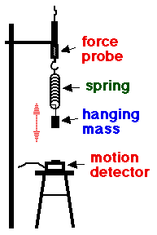

Figure 1 Lab set up for the simple harmonic motion experiment.

**Methods**

In order to test the viability of replacing very accurate and expensive equipment with equipment that is perhaps not as accurate, but appreciably less costly, various algorithms were used to see if it is possible to recreate the data from the lab experiment, as seen in Figure 2. These algorithms included Lagrange’s interpolating polynomial, piece-wise linear interpolation, Newton’s divided difference method, and Neville’s method of polynomial interpolation.

Figure 2 Lab data

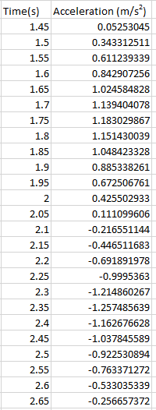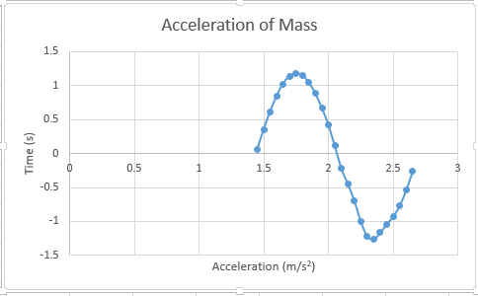

Lagrange’s method was named after Joseph Louis Grange who published the method in 1795, but it was originally discovered in 1779 by Edward Waring. Linear interpolation is believed to have been used since the last three centuries BC by Babylonian astronomers and mathematician, Hipparchus. A description of linear interpolation could be found in text by mathematician Ptolemy (2nd century AD). Newton’s divided difference method was developed by Isaac Newton during the 17th and 18th century. Neville’s method was discovered by Eric Harold Neville during the 20th century. It is fascinating to see how these algorithms were discovered quite some time ago, yet we still use and apply those algorithms today. The results below show how well these techniques hold in the modern world.

**Results**

Based on previous experiments, it was expected that all of the interpolation methods would be fairly close in terms of accuracy except linear interpolation since the lab data followed a sinusoidal curve as opposed to linear data. Interestingly, 3 of the methods were strikingly similar, despite their code being markedly different. For example, Figures 3, 4, and 6 are practically the same, although the actual data directly from the program differ by a femto-degree (10-15), as seen in Figure 7. The three methods that were similar were all polynomial interpolation methods, which is interesting since these methods were expected to be the most accurate. Clearly, as seen in the figures, polynomial interpolation seemed to work fairly well between the endpoints of the lab data, but not as well at the actual endpoints. One particular detail that stands out from the polynomial method is that these methods capture the slight imperfection from the original data from acceleration values 2.25 to 2.5, whereas linear interpolation seemed to fix that minor imperfection.

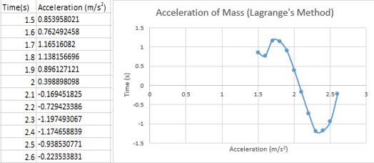

Figure 3 Result of Lagrange's method of interpolation on lab data.

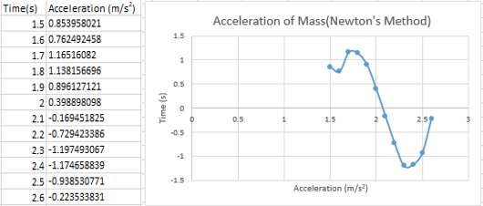

Figure 4 Result of Newton's method of interpolation on lab data.

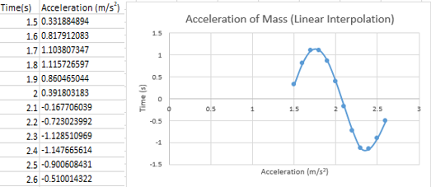

Figure 5 Result of linear interpolation on lab data.

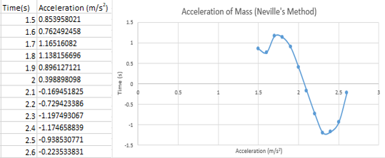

Figure 6 Result of Neville's method of interpolation on lab data.

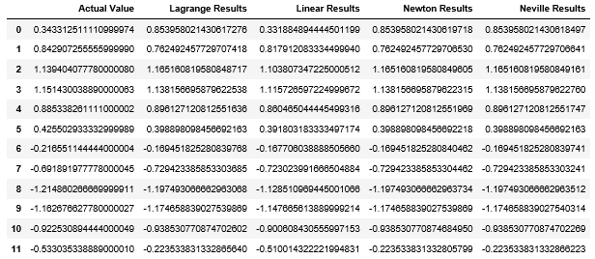

Figure 7 Comparison of results between different methods of interpolation.

A few changes to this experiment could be made to improve the integrity of the results. For example, calculating the error values from the data would be most beneficial in terms of figuring out exactly which method is the most accurate compared to the lab data. Of course, since all the methods, besides linear interpolation, are fairly close in terms of accuracy and precision, it is clear to see that the polynomial interpolation methods stay more true to the lab data (going as far to capture actual imperfections from the data), although it does not seem to work as well with endpoints. This may also be due to human error in coding since the algorithms are fairly complex, so it would also be beneficial if another person perhaps looked through the code and either verified that it is working correctly or if there is perhaps an error in the code.

Another parameter that could be tested from this experiment is position or velocity data since it is also available from the motion camera. This would help visualize if the three polynomial interpolation methods stay consistently similar or if this was true for this particular data set. In addition to more data, the error term could also be taken account, if it is calculated from various experiments and other actual data. This is important since it could help make the three polynomial interpolation methods more accurate and more distinguished from each other. Lastly, exploring other methods of interpolation techniques, such as Stirling’s method or cubic spline, would be beneficial since it is possible that there is a better method better suited for the lab data that was tested on.

**Conclusion**

Perhaps it may be possible to switch out higher end, more expensive equipment in certain settings, such as high schools, for equipment that is a little less expensive and depends more on interpolation techniques to help evaluate the data. As seen from the results of this experiment, it is possible to recreate some data by simply using interpolation techniques, some of which can even capture the same kinds of imperfections from the original data. As computers grow endlessly smaller and more powerful, it may possible to one day combine various interpolation techniques and create a relatively inexpensive tool that is not only useful for capturing motion to an accurate degree of precision, but also for a plethora of other applications.